How to help people play sport
and do arts
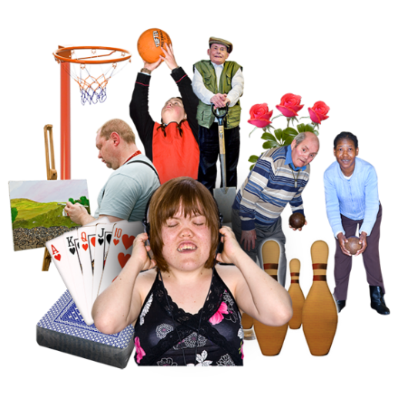
This is an easy read summary of Evaluation of icare lifetime care Community Participation Grants
for use with screen readers

By Suzanna Poredos, Danielle Santos, Christiane Purcal and Ayah Wehbe with help from Council for Intellectual Disability
More information https://www.sprc.unsw.edu.au/research/projects/outcome-evaluation-community-participation-grants /

About icare lifetime care
icare lifetime care is run by the NSW government.
It helps people who are badly injured in a car accident in NSW.
icare lifetime care also gives funding to community groups so people with disability can take part in their community.
This funding program is called Community Participation Grants.

About the report
icare lifetime care asked the Social Policy Research Centre to see whether the funding worked well.
The Social Policy Research Centre is called SPRC for short.
SPRC used different ways to get information such as talking to people, doing surveys and reading reports.

Importance of the project
It is important that people with disability feel part of the community.
It is important that organisations in the community learn how to include people with disability.
It is important that people with disability can take part in activities in their community like sport and arts.
Sport can be:
- Swimming
- Horse riding
- Basketball
- Fitness.
Arts can be:
- Dancing
- Painting
- Taking photos
- Acting and performing.

Good results for people with disability
Projects that worked well had funding to pay for supports such as hoists and Auslan interpreting and mentoring for Deaf people.
Projects that worked well had workshops so people with disability could build their skills.
They also had a mix of people planning and running the project, including people with disability.

How to include people with disability
Train staff to support people with disability better Work through problems together.
Make access easier.
Include people from different backgrounds.
Make relationships with people with disability, professionals and businesses.
Include people with disability to help with activities in the future.

Experiences with the funding program
Most organisations said the funding was good and fair.
Many people with disability and organisations said the funding helped them.
Many people said they will do more activities such as art exhibitions.

Make the program better
Give more funding to projects that are doing well.
Help groups that do not have many resources.
Help people with disability learn more skills.

