Review of the
National Disability Strategy 2010-2020

Easy Read Report

By Suzanna Poredos, Danielle Santos, Christiane Purcal and Ayah Wehbe
with help from Council for Intellectual Disability

More information: https://www.sprc.unsw.edu.au/research/projects/review-national-disability-strategy-2010-2020/
About the review
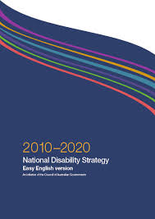 | This report is about the National Disability Strategy 2010-2020.  The National Disability Strategy is a plan to make the lives of people with disability better.  In this document we call it  the Strategy.
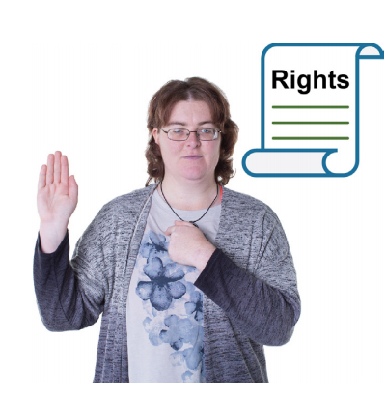 | It helps promote people’s rights and inclusion.
The Strategy is an agreement between all governments in Australia
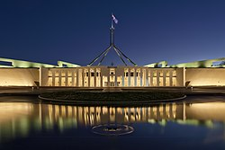 | - Federal
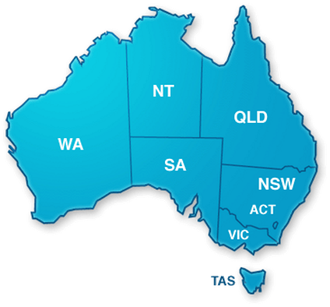 | - States and Territories
 | - Local
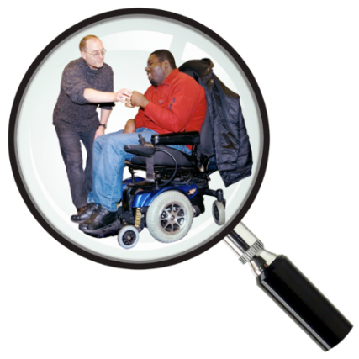 | The review was about how the Strategy works.
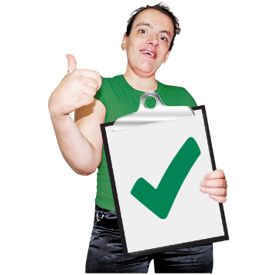 | The review looked at when the Strategy made a difference to people’s lives.  It also looked at when it did not make a difference.
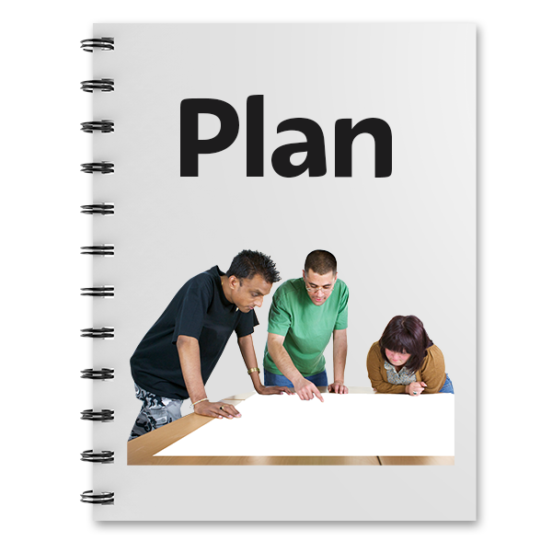 | This will help the governments make a new National Disability Strategy.
People in the project
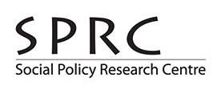 | Researchers from the Social Policy Research Centre did the review.
 | The researchers looked at written documents about the Strategy.
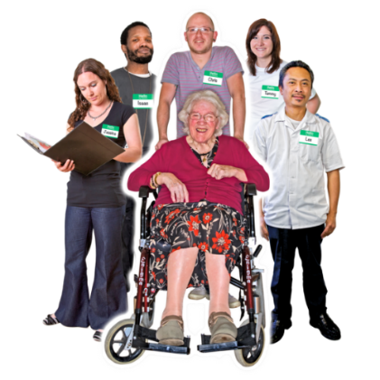  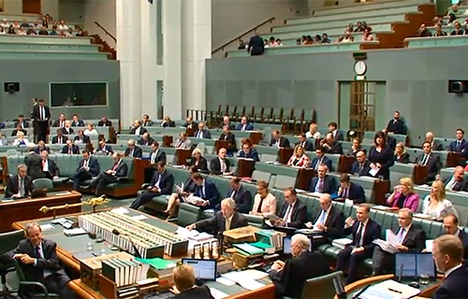 | These documents were written by:  - other researchers  - disability organisations  - governments.
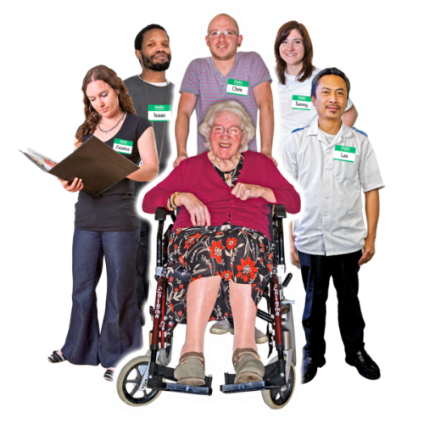 | The researchers talked to:  - organisations that represent people with disability, their carers and friends  - government organisations.
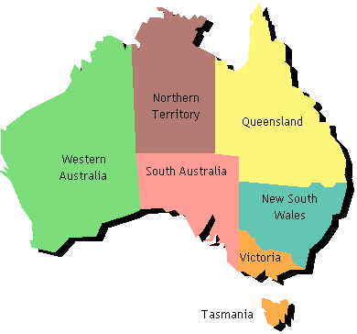 | These talks happened in all Australian States and Territories.
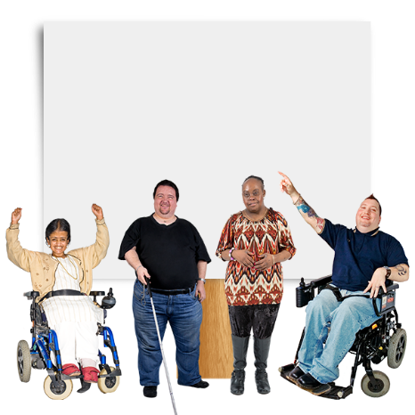 | In the future, the government will talk to people with disability.  The government will ask them what they think about the Strategy.

Findings of the review

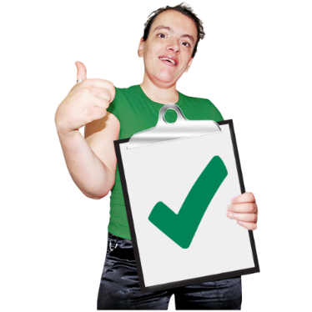  Goals | People said the goals and values of the Strategy were good.
Making a difference | But they said the Strategy did not make a big difference to people’s lives.  This means many goals of the Strategy have not been achieved.
Things to do better in the future
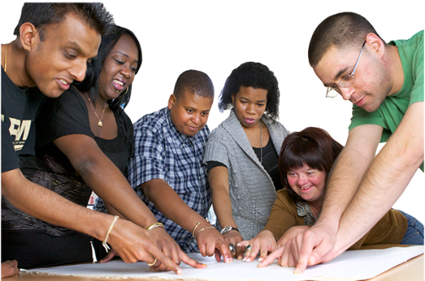 | Involve more people with disability in making disability policy.
 | Work with government and communities to reach more goals.
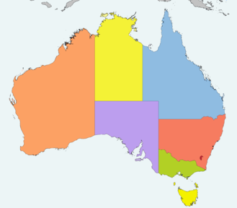 | Give funding to small projects all over Australia so they can make a difference to people’s lives.
 | Focus more on programs for people who cannot use the NDIS.
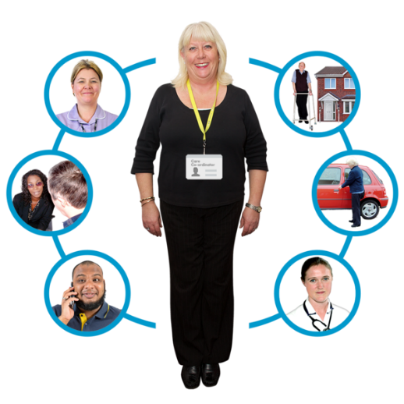 | Work together with NDIS and other services such as:  - health  - housing  - education.
More things to do better
Focus more on including people from different backgrounds such as:
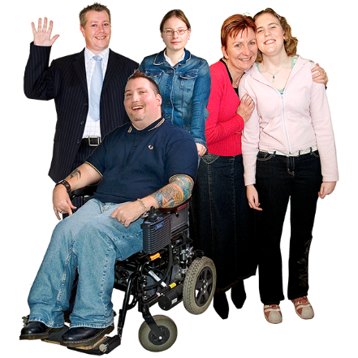 | - People from rural areas  - People of different cultures  - People who speak other languages  - People with different sexualities  - People with different disabilities.

 | Make sure more people know about disability policy.
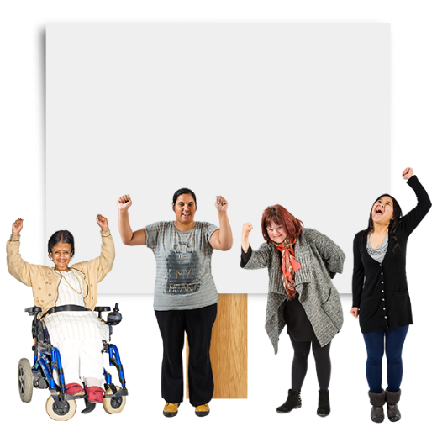  CAMPAIGN | This can be done through media.
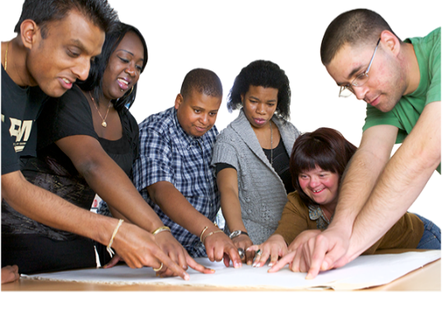 | Get a group of people together to help the government create good projects for people with disability.
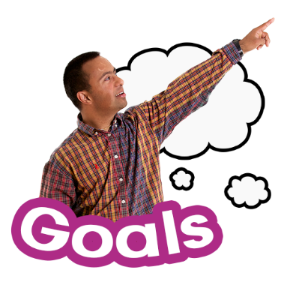 | Change goals and priorities as other things change over time.
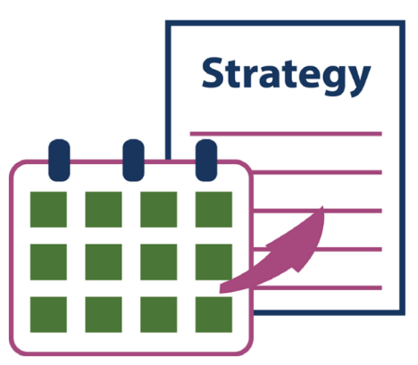 | Make those changes quickly.
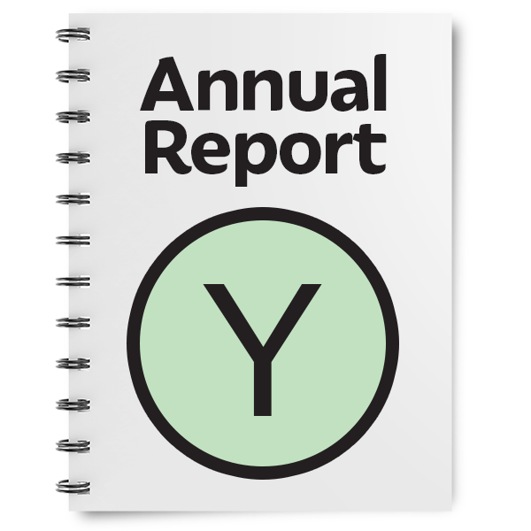 | Write yearly reports about which goals have been achieved.

