Easy Read report about housing for people with disability
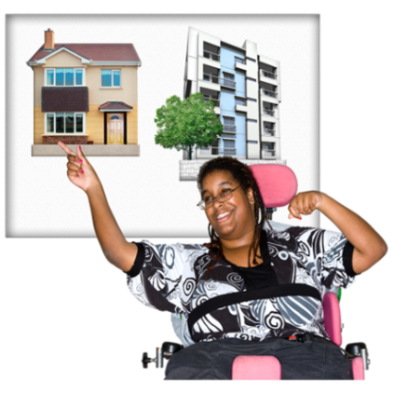
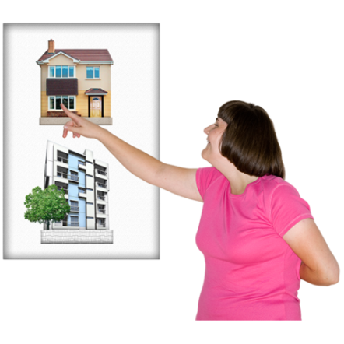
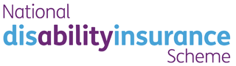
What is this report about?
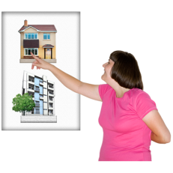
This report is about housing for people with disability under the National Disability Insurance Scheme (NDIS). It is about how to help people with disability live how and where they want to.

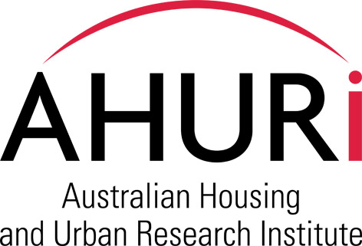Whose report is it?
This report was done for a group that finds out what to do about housing. It is called the Australian Housing and Urban Research Institute (AHURI). They asked for the report to be done.

This report was done by:
- Researchers at two universities – UNSW and RMIT.

AND

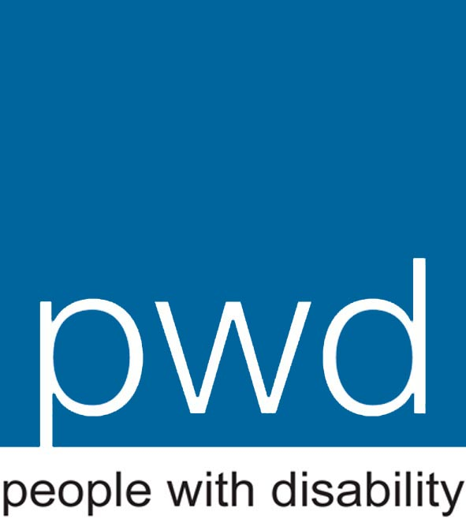
- 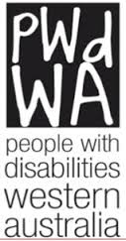Researchers at two disability advocacy organisations – PWDA and PWDWA.

They found out what people thought about housing for people with disability and wrote the report.

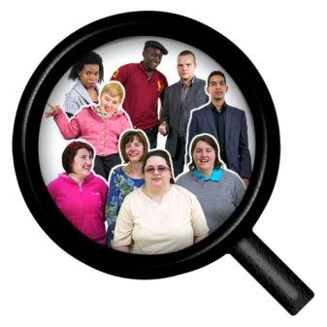
How was this report done?
This report was done by talking with people with disability, families and staff in housing and disability services and in government to find out what they think about housing. It also used some information already collected about everyone in the country.
How and where are people with disability living at the moment?
Many people with disability live differently to people without disability.
As adults, people without disability often live:
- In their own home.

AND

- Alone or with family or friends they choose to live with.

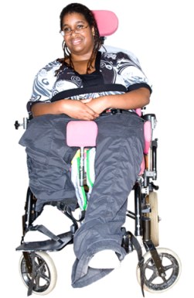
As adults, people with disability often live:
- In group homes or in large places where lots of other people with disability live too.

OR

- With their parents or other family, whether they want to or not.

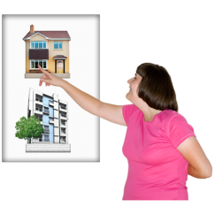
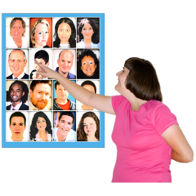
Many people with disability would rather live in their own home with people they choose to live with.

What will happen when the NDIS comes in?

The NDIS is coming.
It will give people with disability more chance to use their funding how they want to.

More people with disability will choose to live in their own home with people they choose to live with. The NDIS can help by paying for a support worker or for equipment if they need it.

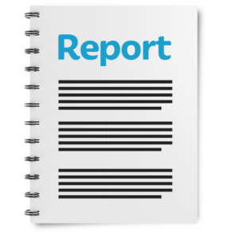
But to live in their own home, people with disability also need to find homes that do not cost too much for them.
At the moment, most homes cost too much for people with disability. The NDIS will not help with the cost of a house.

This report is about:
        - What makes it hard for people with disability to live in their own home.
        - What helps people with disability to live in their own home.
        - How people with disability can find homes that do not cost too much.
What was it like for people with disability who moved into their own home?
We spoke to some people with disability who moved into their own home. Most of them thought that it was good to move into their own home. They said they felt they had:
- More independence

- More privacy

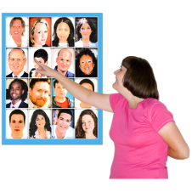

- More choice about who they lived with

- Better health

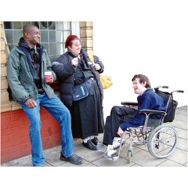
- New friends

There were other things that did not change when people moved into their own home. For example, moving did not change whether people with disability had a job or not.
Some people we spoke to had problems paying for their new home. It cost too much.
What ways can people with disability live in their own home?
There are three ways that people with disability can live in their own home:
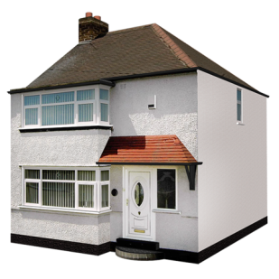
- Social housing
Living in a house that belongs to the government or another organisation. Social housing costs less.

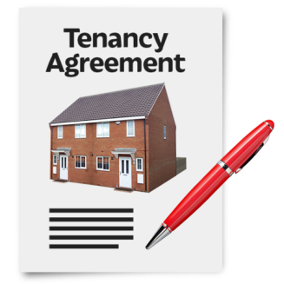

- Private rental
Paying money to live in a house owned by someone else. This is called being a ‘private rental tenant’.

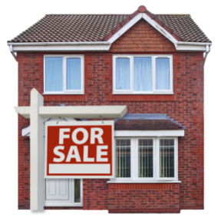

- Home ownership
Buying your own house to live in.

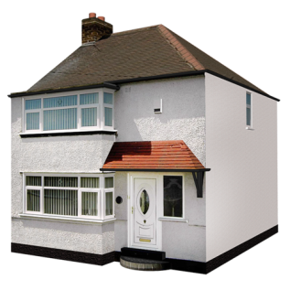
Social housing

What makes it hard for people with disability to move into social housing?
        - There is not enough social housing for all the people who need it.
        - There is a long list of people waiting to move into social housing. People who live with parents or other family or in a group home are not near the top of the list. They have to wait for a long time before they can move into social housing.
        - There is not enough social housing that is accessible for people with disability.

What helps people with disability to move into social housing?
        - Help from staff to get a place in social housing.
        - Getting a place in social housing faster if they have nowhere else to live.
        - Building an accessible house for them or making changes to the house they already live in.

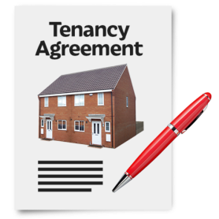
Private rental

What makes it hard for people with disability to move into private rental?
        - It costs too much.
        - Some people who own the houses do not want people with disability living there.
        - Some people who own the houses do not want people who have never rented before living there. Lots of people with disability have never rented before.
        - There are not enough private rentals that are accessible for people with disability
        - There are not enough private rentals that are good for Indigenous people with disability.

What helps people with disability to move into private rental?
        - Having a good relationship with the person who owns the house or is in charge of the rental.
        - The person who owns the house wants to help people with disability.
        - The house does not cost too much because it is in a small town.
        - Sharing the house with other people so it does not cost as much.
Own home
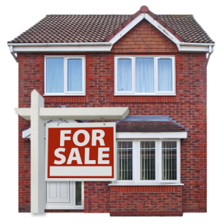

What makes it hard for people with disability to move into their own home?
        - It costs too much.
        - It is hard to borrow money to pay for the house.

What helps people with disability to move into their own home?
        - Family helps with the cost.
        - Buying with other people and sharing the cost.
        - Sharing the cost of the house with a housing organisation. This is called shared-equity.
        - Making changes to a house to make it easy for them to live in.

What should government do to help people with disability move into their own home?
The NDIS will give people with disability more chance to use their funding how they want to. More people with disability will choose to live in their own home. But to do that, the government should do some things to help:

- Build more houses that:

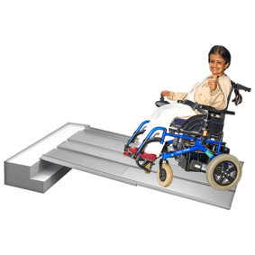

  - Are accessible for people with disability

  - Do not cost too much

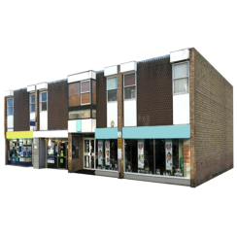
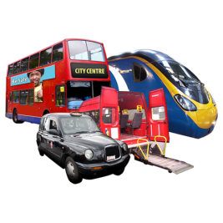

  - Are close to shops and transport

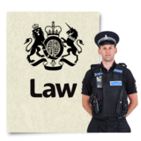
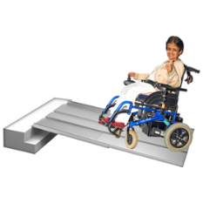
- Make new laws saying that all new houses that are built need to be accessible for people with disability.

- Check with people with disability about what they need in their house to make it good to live in.

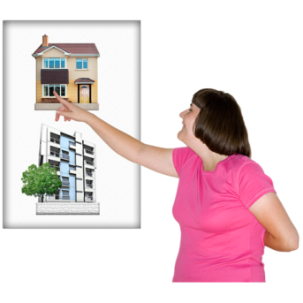

- Give more help for people with disability to make decisions about how and where to live.

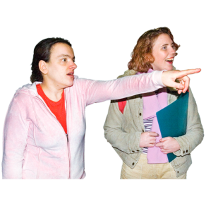

- Give more help for people with disability to search for places to live.

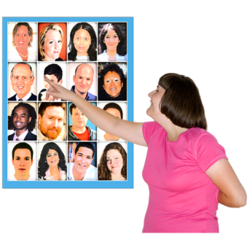

- Make programs to help people with disability pick people who they want to live with. This includes programs to help people with disability get to know more people in their community.

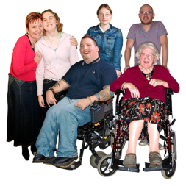
- Make ways to help people with disability and their families pay for housing together with other people, so that they can share the cost.

This report is an Easy Read version of the following main report:
Wiesel, I., Laragy, C., Gendera, S., Fisher, K.R., Jenkinson, S., Hill, T., Finch, K., Shaw, W. and Bridge, C. (2015) Moving to my home: housing aspirations, transitions and outcomes of people with disability, AHURI Final Report No.246. Melbourne: Australian Housing and Urban Research Institute. Available from: <http://www.ahuri.edu.au/publications/projects/p71040>.

This Easy Read report has been written by Ariella Meltzer, Ilan Wiesel, Karen Fisher and Samantha Jenkinson. The pictures are Photosymbols.

